**Ideation Phase**

**Brainstorm & Idea Prioritization Templa**

|  |  |
| --- | --- |
| Date | 15 February 2025 |
| Team ID | LTVIP2025TMID60000 |
| Project Name | Health AI-Intelligent Healthcare Assistant Using IBM Granite |
| Maximum Marks | 4 Marks |

**Brainstorm & Idea Prioritization Template:**

Brainstorming is essential in developing **HealthAI**, an intelligent healthcare assistant that uses **IBM Granite models and Generative AI** to improve patient support. This environment encourages every team member—whether technical or non-technical—to share creative ideas that help users get clearer, faster, and more personalized health insights.

This session will focus on proposing, organizing, and improving features such as **symptom checkers, AI medical chats, treatment plans, and health analytics dashboards**. Whether you're together or remote, use this template to contribute freely and shape innovative AI-driven healthcare solutions.

**Step-1: Team Gathering, Collaboration and Select the Problem Statement**

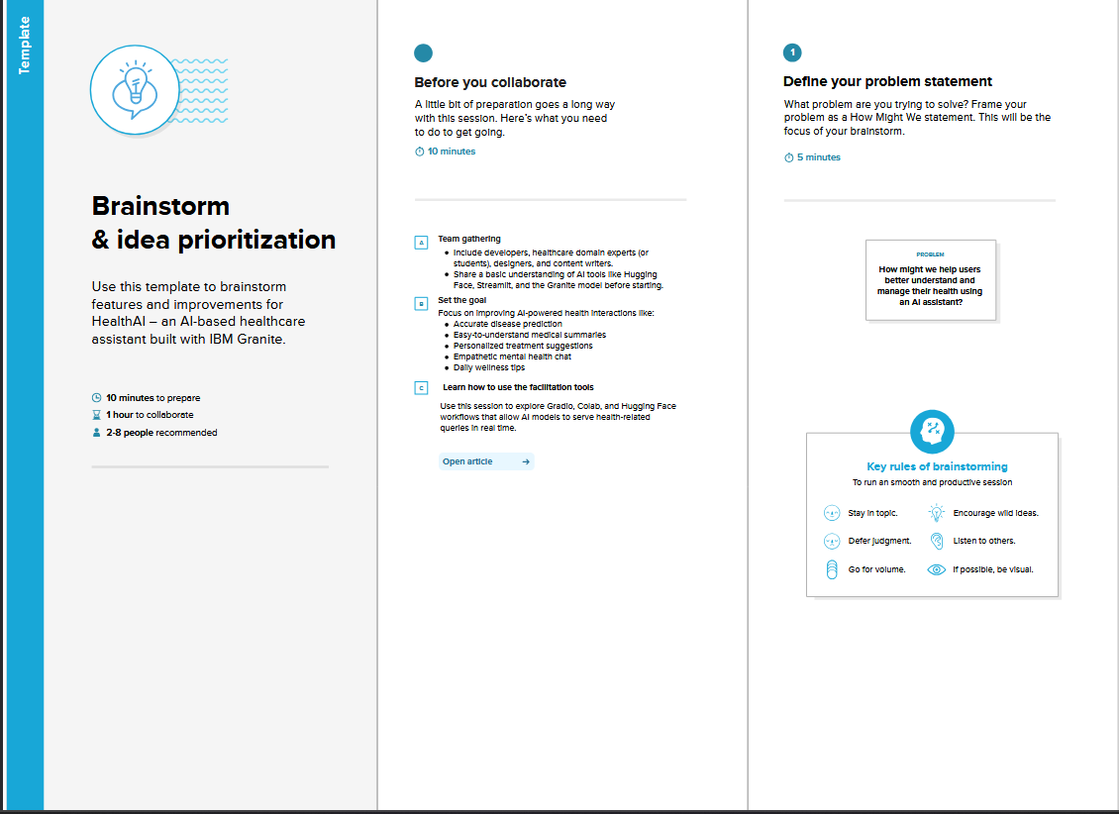

**Step-2: Brainstorm, Idea Listing and Grouping**

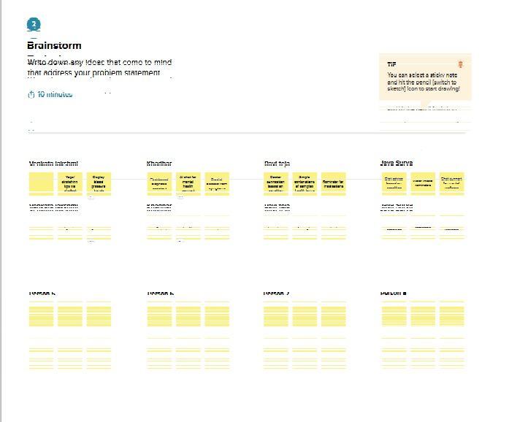

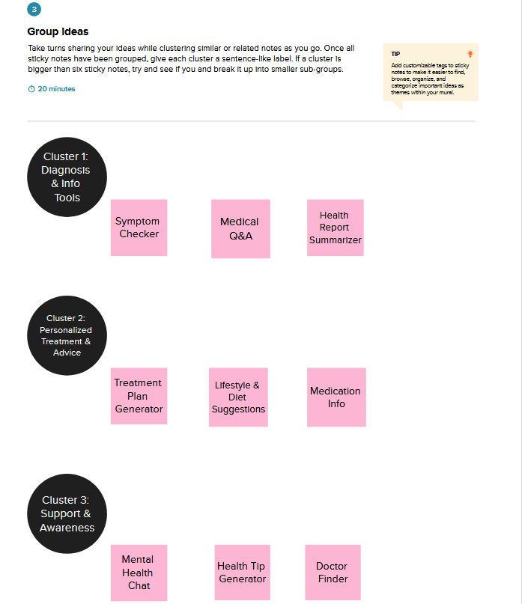**Step-3: Grouping**

**Step-4: Idea Prioritization**

